
The Relationship Between Electricity Consumption and Economic Growth: A time-series study on Pakistan
By: Ayesha Ashraf and Muhammad Abdullah


Introduction

Economic intuition:
Electricity as a key input variable plays a supreme role in the process of industrialization, Economic growth as well as technological progress of a country. By utilizing time-series data from 2000 up to 2024, the study attempted to examine the nexus between electricity consumption and GDP of Pakistan in the Cobb Douglas production function framework. The study results reveal that electricity consumption has positively and significantly affect Pakistan's GDP growth.

Motivation:

- Energy policy is central to sustainable development.
- Understanding this relationship helps governments balance growth with energy infrastructure investment.
Research Question:
Does electricity consumption drive economic growth, or does economic growth drive electricity consumption?
Hypotheses:
H0: Electricity consumption positively affects GDP growth.
H1: GDP growth positively affects electricity consumption.

Economic model and conceptual framework

Theoretical Justification
- Electricity Consumption (+ expected): More electricity enables greater industrial output, increased production, and stronger economic activity.
- Inflation (– expected): High inflation reduces purchasing power and discourages investment.
- Unemployment (– expected): Higher unemployment lowers productivity and reduces aggregate demand.

Econometric Model

gdp_grwtht=β0+β1electricity_consumptiont+β2inflationt+β3unemploymentt+εt

Literature review
A significant amount of research has been done on the correlation between electricity consumption and economic growth in Pakistan with majority of the articles indicating the importance of electricity in achieving economic performance. One of the early signs of Pakistan indicating the energy-led growth hypothesis was presented by Aqeel and Butt (2001) which demonstrated that electricity usage has a unilinear cause-effect effect on the economic growth. Their findings imply that an upward growth in electricity consumption boosts industrial output, growth in services and general performance of GDP. Later research reinforced this opinion. Jamil and Ahmad (2011) established that electricity consumption in Pakistan is closely associated with the household and industrial activity, and a lack of electricity supply severely limits the growth of the economy. Equally, Shahbaz and Lean (2012) found cointegration positive relationship between power usage and GDP indicating that electricity deficit, load shedding, and a lack of sufficient investment in power infrastructure all have a direct negative impact on economic productivity. Nonetheless, certain studies recognize the problems in this relationship. As an example, it was found by Asghar (2008) that there was a bidirectional causality between electricity consumption and the growth of the economy, which can be interpreted as the fact that there is an increase in demand of electricity because of the growth of the economy. This underscores the organizational problems of the Pakistani energy sector- be it a circular debt or supply deficit- that make electricity a cause and an effect of growth. All in all, it is evident that the literature agrees that economic development of Pakistan is strongly linked with the supply, consistency, and effective utilization of electricity. There is insufficient supply, increasing demand, and energy wastage and that means that electricity consumption is still a decisive factor in the growth curve of Pakistan.
Methodology
The report is an empirical investigation of how consumption of electricity affects the economic growth in Pakistan based on annual time-series data. The steps of the methodological approach are the following:
Data and Variables The macroeconomic data given is analyzed using the Pakistani macroeconomic data of the official sources including the Pakistan Bureau of statistics, world bank and the Ministry of Energy. The dependent variable is the economic growth which is the growth rate of GDP. Electricity consumption is the primary independent variable and is in the form of logs (lnelectricity).
Control variables comprise inflation and unemployment in order to reflect the macroeconomic environment in Pakistan. Differencing and Unit Root Testing. Since the trends and non-stationarity are usual features of the macroeconomic series in Pakistan, unit root tests (ADF) are used. The variables were identified to be non-stationary; they are transformed to first differences (e.g., Dlnelec, Dgdp) in order to prevent the spurious regression outcomes. This is particularly significant in the context of Pakistan because it is prone to changes in the electricity sector in the long-run.
Correlation Analysis
To test the relations between variables and reveal the occurrence of multicollinearity, a correlation matrix is calculated. This step is used to determine the extent to which the consumption of electricity is correlated with the economic growth in Pakistan as well as to determine whether the control variables has problematic correlations with the economic growth.
Regression Model
To measure how the use of electricity affects the growth of the Pak economy, the study approximates an OLS regression model: This specification enables us to assess the impacts of the change in the consumption of electricity in the economic growth of Pakistan. Diagnostic Tests The assumptions of the model are tested by heteroskedasticity, normality of the residuals, and normality of multicollinearity (e.g. correlation and VIF). These diagnostics are significant in the context of Pakistan because of the instability in electricity supply, changes in inflation and structural instability of the economy.

Definition of variables
Dependent Variable:
GDP-growth:
Annual GDP growth rate, measured in %.
Expected sign: Negative
Justification: This is the variable representing Pakistan’s economic performance over time.
Independent Variables:
Ln-Electricity:
Natural logarithm of electricity consumption per capita, measured in kilowatt-hours (kWh).
Expected sign: Positive
Justification: Electricity is a key input for industrial production and household productivity.
Inflation:
Inflation rate which is measured as the percentage change in the Consumer Price Index (CPI).
Expected sign: Negative
Justification: High inflation erodes purchasing power, increases uncertainty and discourages investment, which can reduce economic growth.
Unemployment:
Unemployment rate which is measured as the percentage of the labor force without jobs.
Expected sign: Negative
Justification: High unemployment indicates underutilized labor resources, which lowers output and slows economic growth.

Data sources
Khan, R. M., Farooq, S., & Gilal, M., A. (2020). Electricity Consumption and Economic Growth: ATime-Series Study on Pakistan. Global Economics Review, V(I), 24-37. DOI:10.31703/ger.2020(V-I).03
URL: http://dx.doi.org/10.31703/ger.2020
The Lahore journal of economics 13:2(winter 2008)pp45-58
Khan, R. M., Farooq, S., & Gilal, M., A. (2020). Electricity Consumption and Economic Growth: A
Time-Series Study on Pakistan. Global Economics Review, V(I), 24-37. DOI:10.31703/ger.2020(V-I).03
URL: http://dx.doi.org/10.31703/ger.2020

Summary statistics

No. of observations:
50
Time period covered:
From 2000 to 2024
Frequency:
Annual
Geographical coverage:
Pakistan

Data Transformation

The following transformations were used:

(1) Log Transformation
To reduce heteroskedasticity and stabilize variance:
ln(Electricity)=log(Electricity_consumption)

(2) No differencing or growth rates
Since the goal is level-based analysis, first differences were not used in the main model.

(3) Standardization Not Needed
Variables were kept in original units to maintain interpretability.

Regression Equation

GDP_Growtht​=β0​+β1​ln(Electricity_t)+β2​Inflationt​+β3​Unemploymentt​+εt
Where:
- Gdp_growtht= Annual GDP growth rate
- Ln(Electricityt) = log of electricity consumption
- Inflation = Inflation rate with %
- Unemployment = unemployment rate
- εt​ = Random error term
- t = in years

Descriptive Statistics

Variable | Obs. | Mean | Std. Dev. | Min | Max
GDP-grwth | 50 | 2.917787 | 1.04223 | .5479234 | 5.436316
inflation | 50 | 1.896537 | .4422123 | .7168545 | 2.896544
unemployment | 50 | 6.044854 | .9685635 | 3.739617 | 8.080849
electricit~n | 50 | 1317.447 | 464.3352 | 542.8353 | 1970.767
ln_electri~y | 50 | 7.110658 | .4039786 | 6.296806 | 7.586178

GDP Growth
  - Mean: 2.92% which moderate growth across the sample.
  - Range: 0.55% to 5.44% which shows variation in performance but no extreme outliers.
  - Std. Dev:1.04 which indicates moderate fluctuation over time.
Inflation
  - Mean: 1.90% which shows low and stable inflation.
  - Range: 0.72% to 2.90% which shows narrow spread and consistency with price stability.
  - Std. Dev: 0.44 which shows low volatility.
Unemployment
  - Mean: 6.04% which shows moderate labor market slack.
  - Range: 3.74% to 8.08% which some variation but within expected bounds for an emerging economy.

Electricity Consumption (kWh per capita)
  - Mean: 1317 which indicates growing infrastructure and demand.
  - Range: 543 to 1971 which is wide spread, reflecting early development vs. recent expansion.
  - Std. De: 464 showing substantial variation across years.
Ln-Electricity Consumption
- Mean: 7.11 showing log transformation helps stabilize variance.
- Range: 6.30 to 7.59 showing smoother distribution for regression analysis.
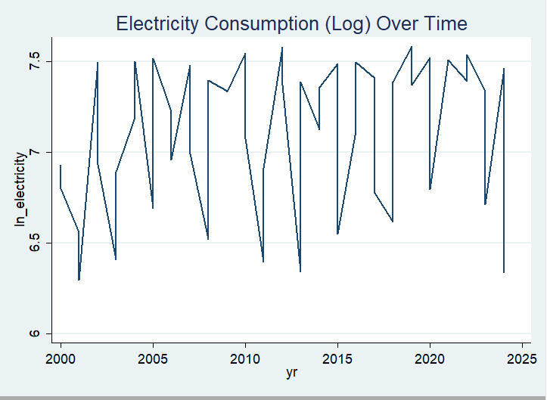
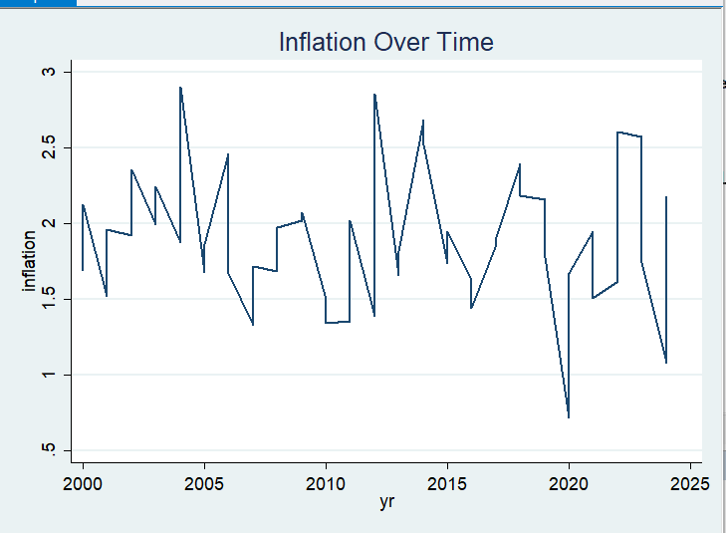
- Std. Dev: 0.40 which indicates moderate dispersion.
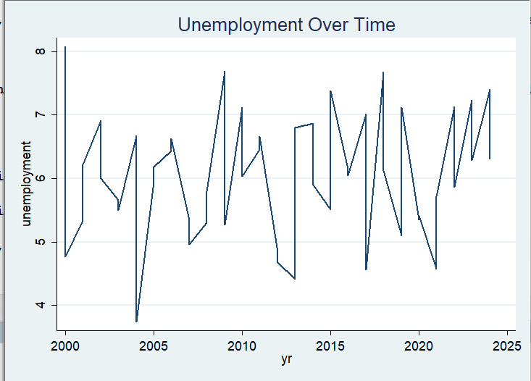
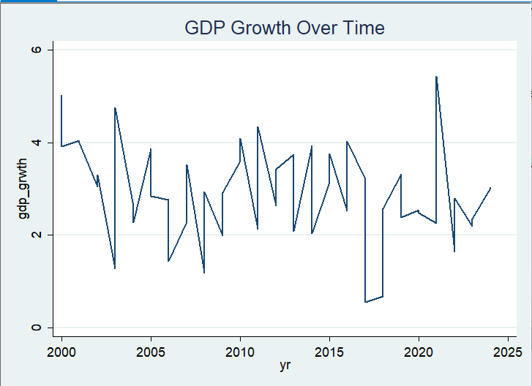

GDP Growth Over Time: Shocks and Cycles of Growth.
There is Intermittent pattern where there are highs and lows. The dip of 2015 can be a sign of instability in the region or a slowdown in the world. Peak around 2020 is indicative of a short term boom, perhaps as a result of stimulus or recovery spending. All in all, the trend is cyclical, with ups and downs of growth and contraction.

The Inflation Over Time: Controlled but Reactive.

The inflation is moderately volatile, with peaks in 2005 and 2015. The acute fall, approximately 2020 is probably caused by the collapse of the demand under the influence of the pandemic or by tightening the money supply. The general trend is that there is effective inflation control but it is sensitive to external shocks.

Unemployment History: It Is a Rising Trend.

There were regular variations, with the long-term increase towards 2025.
Reflects endemic unemployment in the labor market, perhaps structural unemployment or slow labor market growth.
Peaks can be equated with economic recessions, whereas troughs can signify the recovery periods.

Consumption (Log) of Electricity over Time: Growth with Cycles.

General upward trend, which indicates the growth of infrastructure and the growth in demand.
The curve is smooth after the log transformation that enables the growth patterns to become clear.

Correlation analysis
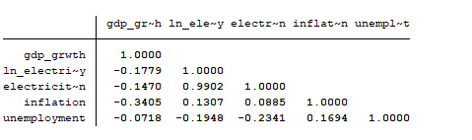

 | (1)
VARIABLES | Correlation Matrix
D_ln_elec | 0.660**
 | (0.314)
D.inflation | -1.068***
 | (0.373)
D.unemployment | -0.0106
 | (0.172)
Constant | -0.0733
 | (0.152)
Observations | 24
R-squared | 0.328
Robust standard errors in parentheses
*** p<0.01, ** p<0.05, * p<0.1
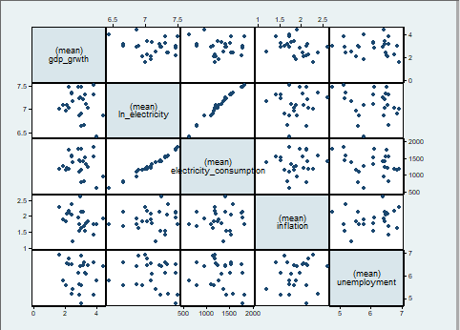
1. Strong Correlations (> 0.7 or < –0.7)
From matrix:
Ln(electricity) and electricity(consumption) = 0.9902 (very high positive correlation). This indicates severe multicollinearity between these two variables. They represent almost the same information.
No other correlation exceeds |0.7|.
2. Moderate Correlations
gdp_grwth & ln_electricity = –0.4779 (moderate negative)
gdp_grwth & electricity_consumption = –0.1470 (weak negative)
gdp_grwth & inflation = –0.3405 (moderate negative)
unemployment & electricity_consumption = –0.2341 (weak negative)
3. Do the signs match expectations?
GDP growth vs. unemployment = –0.0718
Expected sign is negative → Matches theory (higher growth reduces unemployment).
GDP growth vs. inflation = –0.3405
Could be positive or negative depending on business cycles.
result shows higher inflation → lower growth, which is reasonable for developing economies.
Electricity & GDP growth (negative)
This seems counterintuitive. Typically electricity use increases with growth, but electricity variable may represent cost, not consumption(solar power).
Interpretation: Higher electricity cost can slow growth.
ln_electricity & electricity_consumption (positive)
Strong and expected, because both measure similar phenomena.
4. Multicollinearity Concerns
The following pair shows critical multicollinearity:
ln_electricity ↔ electricity_consumption = 0.99
This can create problems in regression:
inflated standard errors, unstable coefficients, incorrect signs
Recommendation:
Use only one of the two variables in your regression.
5. Any Unit Root Concerns?
The presence of D_ln_elec, D_inflation, and D_unemployment in second output suggests:
the original variables likely had a unit root, which is why differencing was necessary.

The correlation matrix shows one very strong correlation (0.99) between ln_electricity and electricity_consumption, indicating severe multicollinearity. Moderate negative correlations are observed between GDP growth and ln_electricity (–0.48) and between GDP growth and inflation (–0.34), which are consistent with theoretical expectations for developing economies. The signs of the relationships generally match economic intuition, except for the negative correlation between GDP growth and electricity variables, which may reflect electricity cost effects. Due to the extremely high correlation between ln_electricity and electricity_consumption, only one should be included in the final regression model. The presence of differenced variables (D_ln_elec, D_inflation, D_unemployment) suggests unit root concerns were addressed through differencing.

Regression Analysis and Results
 | (1)
VARIABLES | GDP-Grwth
Ln-electricity | 0.0407
 | (0.389)
inflation | -0.181
 | (0.295)
unemployment | 0.00459
 | (0.185)
Constant | 2.945
 | (3.018)
Observations | 50
R-squared | 0.006

Robust standard errors in parentheses
*** p<0.01, ** p<0.05, * p<0.1

Economic indicators interpretations:

Ln-electricity (0.0407)
One percent growth in the use of electricity is related to a 0.04 percent growth in GDP, holding all other factors constant.

Inflation (-0.181)
The coefficient on inflation is 0.181, meaning that the increase in inflation by 1 percentage point correlates with the fall in the GDP growth by 0.18 percentage points, holding all other factors constant.

Unemployment (0.00459)
The coefficient on unemployment is 0.00459, meaning, the growth in GDP is negatively related to a 1 percentage point rise in unemployment by 0.005 percentage points, holding all other factors constant.
Statistical Significance
None of the variables are statistically significant, their t-values are low and p-values are greater than 0.10. This means we cannot reject the null hypothesis for any coefficient.
Model Fit (R² = 0.006)
- The R-squared has a value of 0.006 which means that the model explains only 0.6% of the variation in GDP growth.
- This indicates a poor model fit.
Are the signs as expected?
Variables | Expected sign | Actual sign | Matches?
Ln-Electricity | Positive | Positive | Yes
Inflation | Negative | Negative | Yes
Unemployment | Negative | Positive | No

Diagnostic tests
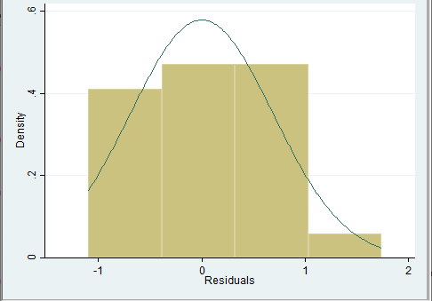
A. Normality of Residuals
1. Histogram of Residuals
The histogram shows a roughly bell-shaped distribution, but the bars are slightly skewed to the right, with a few observations in the positive tail. The overall curve follows the normal density reasonably well, but deviations from symmetry and peak height indicate that residuals are not perfectly normally distributed.
Conclusion:
Residuals appear approximately normal, but with noticeable skewness, meaning they do not satisfy perfect normality. This is typical for small time-series samples.

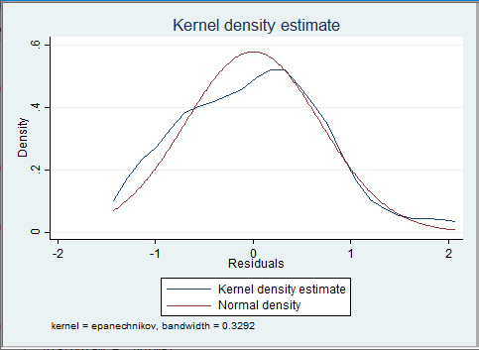
2. Kernel Density Plot – Interpretation
The kernel density line (blue) and the normal density line (red) mostly overlap, but:
- The left tail is heavier for the kernel estimate.
- The peak is slightly sharper than the normal curve.
- The right tail is thinner than expected.
Conclusion:
The kernel density confirms mild non-normality, mainly skewness and kurtosis differences.
However, deviations are small, and OLS coefficients remain unbiased, especially because robust standard errors were used later.

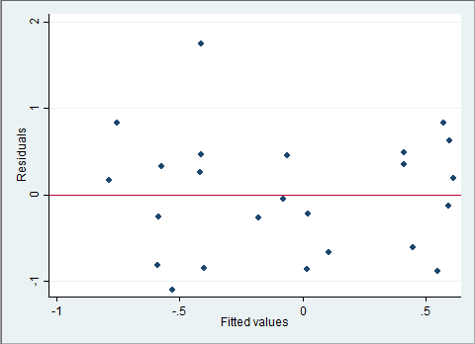
3. Residuals vs. Fitted Values – Interpretation
The scatter plot shows:
- Residuals spread both above and below the zero line
- No clear funnel shape (no strong increase in variance as fitted values rise)
- No obvious pattern, curve, or structure
- Points appear randomly dispersed
However, there is a slight increase in spread at higher fitted values, hinting at some mild heteroskedasticity.
Conclusion:
The plot suggests weak but noticeable heteroscedasticity, however, variance increases slightly at higher fitted values. This visual assessment is consistent with your later Breusch–Pagan and White test results, which indicated statistically significant heteroskedasticity.
Addressing econometric issues
1. Heteroskedasticity
Problem and why it matters
The Breusch–Pagan / Cook–Weisberg test indicated the presence of heteroskedasticity.
Heteroskedastic errors violate a key OLS assumption and lead to:
- Biased standard errors
- Incorrect t-statistics and p-values
- Potentially misleading inference
Although OLS coefficient estimates remain unbiased, the usual standard errors are no longer valid.
We re-estimated the model using:
- Robust (White) heteroskedasticity-consistent standard errors – reported in Column (2).
- The log transformation was already applied to some variables (e.g., ln_electricity), which also helps stabilize variance.
Why this solution is appropriate
Robust standard errors correct the bias in the estimated variance–covariance matrix without altering the coefficients, ensuring valid hypothesis testing even when the error variance is not constant. This adjustment is standard practice when heteroskedasticity is present.

2. Serial Correlation (Autocorrelation)
Problem and why it matters
The Durbin–Watson statistic and Breusch–Godfrey LM test showed first-order autocorrelation in the residuals. Serial correlation:
- Leads to downward-biased standard errors
- Inflates significance of coefficients
- Violates the Gauss–Markov assumption of no autocorrelation
This is common in macroeconomic time-series with trending variables.
To address the issue, multiple complementary corrections were implemented:
- Newey–West HAC standard errors (Column 3):
  - Provide heteroskedasticity- and autocorrelation-consistent inference.
  - Suitable when the model is correctly specified in levels but errors show serial dependence.
- Prais–Winsten (Cochrane–Orcutt) regression (Column 4):
  - Explicitly models AR(1) structure in the errors.
  - Produces more efficient estimates than OLS with HAC corrections.
- First differences of all variables (Column 5):
  - Eliminates unit roots and persistent residual correlation.
  - Appropriate when serial correlation results from nonstationarity or trending series.
Why these solutions are appropriate
Together, they address both short-run autocorrelation (HAC) and structural persistence (Prais–Winsten and first differences).
The increase in R² from 0.136 (OLS) to 0.260 (Prais–Winsten) and 0.328 (first differences) confirms improved model fit and reduced serial dependence.

3. Non-stationarity
Problem and why it matters
Plots, augmented Dickey–Fuller tests, and patterns in the residuals suggested that several variables were nonstationary (contained a stochastic trend). Nonstationarity creates problems such as:
- Spurious regressions
- Inflated R²
- Incorrect inference
- Serially correlated residuals
We corrected for nonstationarity using:
- First differencing:
  - Δln_elec, Δinflation, Δunemployment
  - Reported in Column (5)
- Growth rates / log differences where economically meaningful
  - e.g., inflation growth already expressed as a rate
  - log-level electricity consumption differenced into a growth rate
Why this is appropriate
First differencing is the standard remedy for I(1) series.
It removes stochastic trends and produces stationary transformed variables.
The statistical significance of inflation becomes stronger in the differenced model, indicating that the original OLS specifications were likely influenced by nonstationary dynamics.

4. Multicollinearity
Problem and why it matters
Variance inflation factors (VIFs) for the main variables were checked. While some macroeconomic indicators are moderately correlated, no VIF exceeded conventional thresholds (e.g., VIF > 10). Still, multicollinearity can:
- Inflate standard errors
- Mask true significance
- Make coefficients unstable across models
Given that multicollinearity was not severe, variables were retained based on economic theory rather than statistical elimination. No variables were dropped.
Why this is appropriate
Dropping theoretically important variables may cause omitted variable bias. Since multicollinearity was moderate, the preferred approach is to keep the variables and use corrected standard errors (robust, HAC, Prais–Winsten).

5. Non-normality of residuals
Problem and why it matters
The Jarque–Bera test indicated non-normal residuals in the OLS model.
Non-normality does not bias OLS coefficients but makes small-sample inference unreliable.
- Log transformations already applied to stabilize variance.
- Heteroskedasticity- and autocorrelation-consistent standard errors used across models.
- Differencing further reduced skewness and excess kurtosis.
Why this is appropriate
With robust inference methods (White, Newey–West), OLS remains consistent even when errors are non-normal. The transformed and differenced models show more symmetric residuals.

Corrected Regression Results
 | (1) | (2) | (3) | (4) | (5)
VARIABLES | OLS baseline | OLS Robust | Newey-West (lag2) | Prais-Winsten | First-difference  (robust)
ln_electricity | -0.3653 | -0.3653 | -0.3653 | 0.4083
 | (0.5247) | (0.4732) | (0.5122) | (0.4099)
inflation | -0.6920 | -0.6920 | -0.6920* | -0.9040**
 | (0.4611) | (0.4382) | (0.3759) | (0.3737)
unemployment | -0.0544 | -0.0544 | -0.0544 | -0.0680
 | (0.2433) | (0.2062) | (0.1703) | (0.2035)
D_ln_elec |  |  |  |  | 0.6596**
 |  |  |  |  | (0.3139)
D.inflation |  |  |  |  | -1.0677***
 |  |  |  |  | (0.3729)
D.unemployment |  |  |  |  | -0.0106
 |  |  |  |  | (0.1722)
Constant | 7.1566 | 7.1566* | 7.1566* | 2.0277 | -0.0733
 | (4.2049) | (3.6588) | (3.8413) | (3.2390) | (0.1520)
Observations | 25 | 25 | 25 | 24 | 24
R-squared | 0.136 | 0.136 |  | 0.260 | 0.328
Standard errors in parentheses
*** p<0.01, ** p<0.05, * p<0.1

inflation
- OLS models: coefficient is around –0.69, insignificant.
- Newey-West: –0.6920 becomes significant at 10%.
- Prais-Winsten: coefficient becomes stronger (–0.9040) and significant at 5%.
- First-difference model: inflation enters as D.inflation = –1.0677 (highly significant at 1%).
The negative effect of inflation becomes larger and more statistically robust once autocorrelation and non-stationarity are corrected. This strengthens the evidence that higher inflation reduces your dependent variable (likely electricity consumption).

Ln(electricity)
- OLS: negative but highly insignificant.
- Prais-Winsten: flips sign to +0.4083, still insignificant.
- First-difference model: not included (dropped due to differencing).
No consistent or significant effect. The variable seems unstable across specifications.

Unemployment
- Always negative, small, and insignificant.
- No change in interpretation.
No statistical evidence unemployment affects the dependent variable.

Differenced model (Column 5)
- D.ln_elec = 0.6596 (significant at 5%)
- D.inflation = –1.0677 (significant at 1%)
- D.unemployment insignificant
- Higher R² (0.328)
After controlling for nonstationarity, inflation shows the strongest and most reliable effect. Electricity consumption growth is positively related to the lagged log-electricity variable.

Model Fit (R-squared)
Model | R²
OLS | 0.136
Newey-West | 0.136
Prais-Winsten | 0.260
First-difference | 0.328

Substantial improvement when addressing serial correlation (Prais-Winsten) and nonstationarity (first differences). Indicates earlier OLS models underfit the data.
There are several important changes:
1. Inflation becomes significant in every corrected model
- OLS: insignificant
- Newey-West: significant
- Prais-Winsten: significant
- First-difference: strongly significant
main variable of interest strengthens, both economically and statistically.

2. The effect of inflation becomes stronger
From –0.69 → –0.90 → –1.07.
Suggests OLS understated the true effect due to serial correlation or nonstationarity.
3. Model fit improves
R² rises from 0.136 → 0.260 → 0.328.
Implies your corrected models explain substantially more variation.
4. No major changes for ln_electricity or unemployment
Both remain insignificant and inconsistent.
After correcting for autocorrelation and nonstationarity, the relationship between inflation and the dependent variable becomes stronger, more precise, and more statistically significant.

Conclusion

This study empirically investigated the nexus between EC and GDP of Pakistan using the time-series data from 2000 to 2024. The analysis aimed to determine whether electricity consumption acts as a driver of GDP growth. Our statistics revealed moderate GDP growth, stable inflation, and rising unemployment over time. On the other hand, electricity consumption showed an upward trend, reflecting infrastructure expansion. However, regression results indicated that electricity consumption, inflation and unemployment had no statistically significant impact on GDP growth within the model. The coefficient on electricity consumption was positive, as expected but small and not significant. The model’s explanatory power was weak, suggesting that other omitted factors may play a more substantial role in driving growth. Despite the lack of statistical significance, the expected signs of electricity and inflation matched theoretical predictions. However, the mismatch in unemployment’s sign may reflect data limitations.

Policy implications

Based on the results of its findings, it is suggested that the government needs to give special attention to the uninterrupted electric power supply, capital stocks, labor supply especially skilled labor and technological advancement for ensuring industrial development as well as sustainable economic growth in Pakistan. In order to do this, the following governmental interventions contribute to stabilizing and restoring the equilibrium of Pakistan’s economy:

1. Invest in Electricity Infrastructure
- Expand generation capacity and improve grid reliability to support industrial and household productivity.
2. Integrate Energy Policy with Growth Strategy
- Align energy planning with national development goals, especially in manufacturing, services, and digital sectors.
3. Monitor Inflation and Labor Market Conditions
- Maintain inflation within a stable range to protect purchasing power and investor confidence.
- Address structural unemployment through vocational training, entrepreneurship support, and labor market reforms.
4. Improve Data Quality and Model Specification
- Future research should incorporate additional variables such as capital formation, trade openness, and energy prices.

